CSC 575: SPECIAL TOPICS IN COMPUTER SCIENCE

MATRIC NUMBER: 214853

NAME: CHRISTIANA INIOLUWA ADISA

TOPIC

Crop Suitability Prediction for Agricultural Fields  
Using Data Science

Introduction

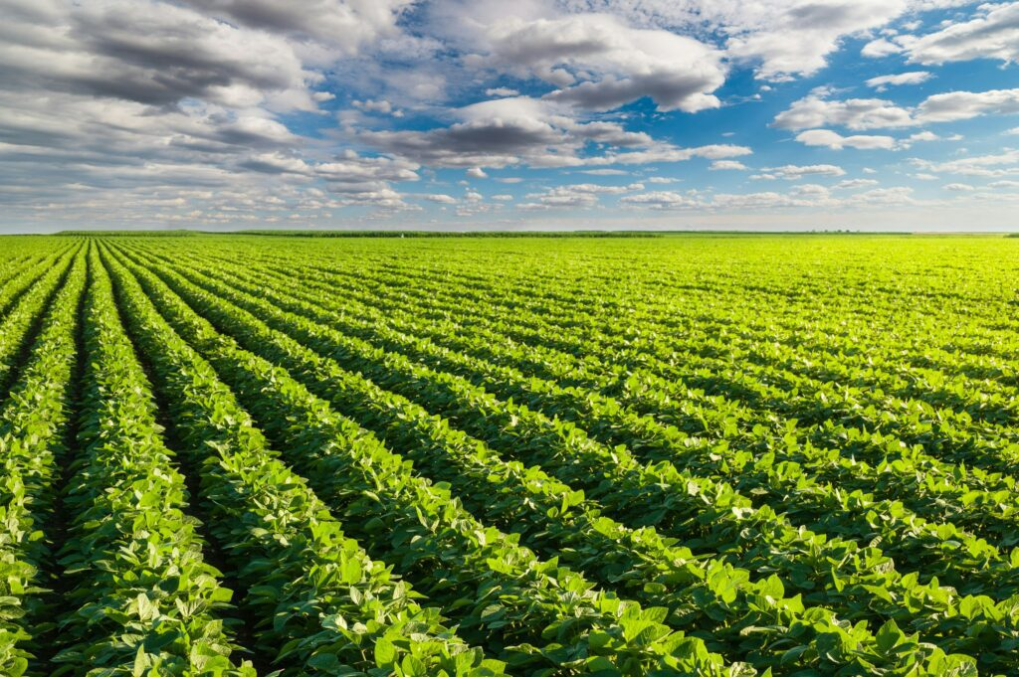

Background

Agriculture plays a vital role in global food security and economic development. However, traditional crop selection methods rely on experience and trial and error, which can lead to suboptimal yields and inefficient resource utilization. With advancements in data science and machine learning, predictive models can analyze soil composition, climate conditions, and historical crop data to recommend the most suitable crop for a given location.

Problem Statement

Farmers and agricultural firms often lack the tools and data to determine which crops are best suited for their fields. This can lead to poor resource utilization, reduced yields, and environmental stress. A reliable, data-driven system to recommend suitable crops is needed and this project addresses this issue by developing a machine learning-based crop suitability prediction system.

Aim

To develop a machine learning-based system for predicting crop suitability using soil and climate data.

Objectives

* Collect and preprocess soil, climate, and crop data.
* Train a machine learning model to predict crop suitability.
* Evaluate and improve the model for accuracy and usability.
* Develop a user-friendly interface for farmers to input field data and get crop recommendations.

Significance

* Enhances agricultural efficiency by reducing guesswork in crop selection.

Supports sustainable farming practices by recommending crops suited to specific environmental conditions.

* Provides a scalable solution for regions experiencing climate change-related agricultural challenges.

Dataset Overview

The data set used in this project was collect from Kaggle, an online contains the following attributes:

* Nitrogen (N): Ratio of nitrogen content in soil (kg/ha). Essential for vegetative growth.
* Phosphorus (P): Ratio of phosphorus content in soil (kg/ha). Important for root development.
* Potassium (K): Ratio of potassium content in soil (kg/ha). Affects plant metabolism and water uptake.
* Temperature: Measured in degrees Celsius. Influences seed germination and growth cycles.
* Humidity: Relative humidity in percentage. Affects transpiration and disease susceptibility.
* pH: pH value of the soil. Determines nutrient availability and microbial activity.
* Rainfall: Annual rainfall in mm. Essential for crop hydration and growth.
* Label: The crop type that is suitable for the given conditions. Includes 22 unique crop varieties.

The